To Whom It May Concern
We would like to take the opportunity to invite companies in the community to consider promoting your brand at Jozini Mall by means of an exhibition, activation or promotion.
Exhibitions and promotions offer exhibitors the opportunity to present their products and services to customers visiting the centre. It is through this effective marketing opportunity that exhibitors are able to establish relationships with their existing customers, as well as develop new relationships with potential customers.
This document outlines our policy details and a floor plan outlining the court areas.
For bookings contact the landlord’s office at:
Tel: 034 312 5997/8
Email: admin@novis.co.za
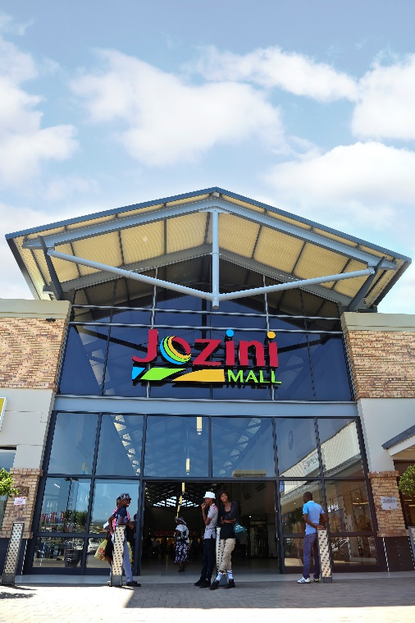
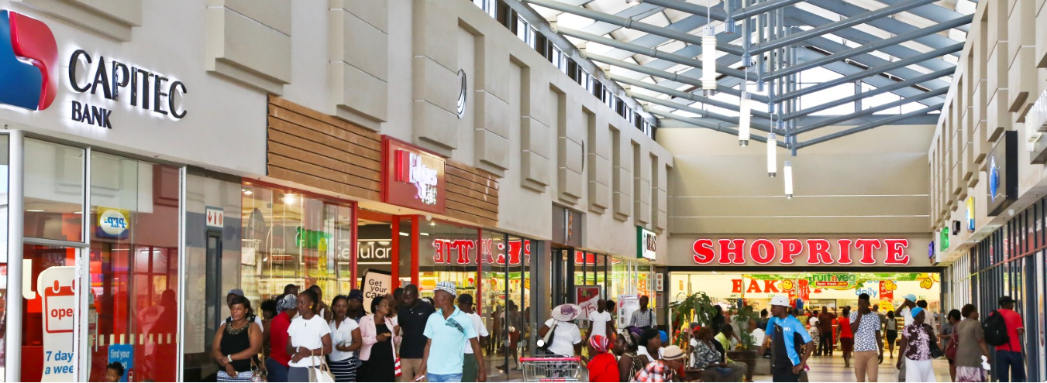

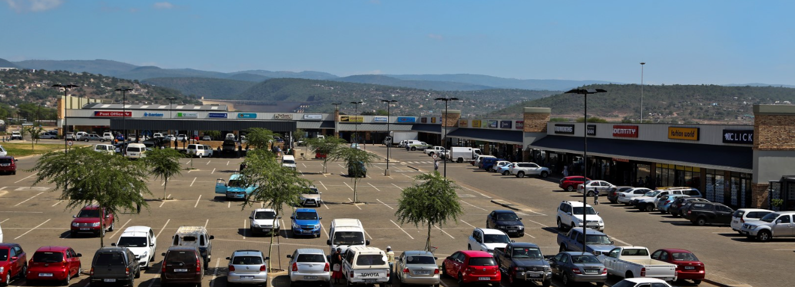

GENERAL FACTS
REGION | Jozini, Kwa-Zulu Natal
TYPE OF CENTRE | Convenience Centre
PHYSICAL ADDRESS | 8B Vuma Street, Jozini
WEBSITE ADDRESS | www.jozinimall.co.za
SIZE | 18 215 m2
TOTAL NO. OF PARKING BAYS | 510
TOTAL NO. OF STORES | ~64
AVERAGE MONTHLY CAR COUNT | ~130 000
ANCHOR TENANTS | Shoprite, Cashbuild, Roots
LANDLORD | Greater Atlantic Properties (Pty) Ltd  60 Sutherland Street, Newcastle

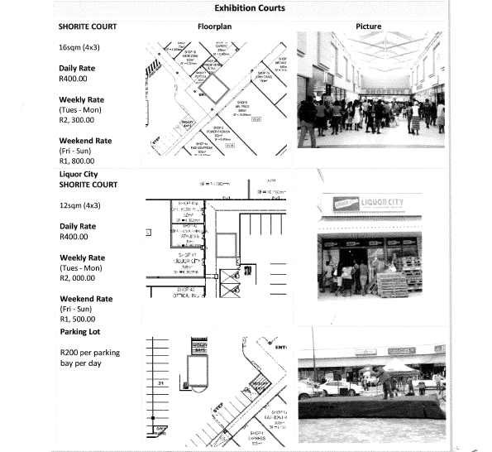
COURT DETAILS AND RATES

PLEASE NOTE:
- The above rates are excluding VAT charged @ 15%
- Daily rates are only to be taken during the week. Full week packages run Tuesday to Monday.
- Absolutely no cash will be accepted.
- No equipment is provided, only court space.
- We have a process and apply a 3-strike policy. To ensure compliance with the outlined process, a 3-strike policy may be implemented. This policy serves as a structured approach to ensure that all exhibiters have equal opportunity. It addresses non-compliance or failure to adhere to the required steps. Upon a third failure to comply with the process, the applicant faces disqualification from future participation. The applicant will be notified of this final action, and no further chances will be provided.

PROCESS
- Application:
The first step involves the submission of a formal application. The applicant provides all necessary information, which includes the purpose of the project, what type of products or services will be promoted, personal or business details and any relevant supporting material. Kindly take the time to submit a fully completed application. Failure will result in one noted strike as a deterrent to avoid added time spend on administrative duties.

- Approval:
After the application is submitted, it undergoes a review process. The board evaluates the application based on set criteria, such as alignment with the community’s needs and tenants at the shopping centre. Once the application is evaluated, the applicant receives either approval or rejection. Approval might come with conditions or additional requirements.
The following will NOT be permitted:
  - Street collections or raffles
  - Betting or gambling
  - The promotion or sale of any product which does not suit the image and brand of the centre.
  - Distribution of pamphlets, flyers, brochures or any advertising material within the Centre or in the parking areas.
  - No Hawkers, vendors and pets are permitted in the centre or in the parking areas.

- Calendar Booking:
If the application is approved, the applicant’s requested dates will be provisionally booked, pending payment. Note that limited exhibition space is available and alternative dates might be suggested. Please submit a written change of date or cancellation if you are no longer interested in the reserved dates. Failure will result in one noted strike. This is to ensure that nobody prevents someone else from taking advantage of this offer.

- Payment:
The applicant will receive a pro-forma invoice to proceed with payment. Proof of such payment must be sent to admin@novis.co.za to secure the booking. Failure will result in one noted strike. This allows us to ensure that we are prepared for your arrival. You will receive an invoice and statement for your records.

PROMOTIONAL POLICY
The following will apply to ALL Promotions held at Jozini Mall:
  - Centre Management reserves the right of admission.
  - Exhibitors should be mindful to avoid confusing customers about their role. Exhibitors are independent entities and not representatives of the Landlord or Management.
  - No amplified music may be played without prior consent from the Centre Management.
  - Tables and chairs to be arranged by the exhibitor and will be for exhibitor’s expense. (Negotiable depending on quantity required.)
  - The height restriction is 1.8m throughout the Centre.
Rules for approved promoters:
  - Exhibitors should treat customers with respect, ensuring a welcoming atmosphere and enjoyable shopping experience, while strictly avoiding any form of harassment. Complaints from customers will count as three strikes.
  - No promotions will disturb the normal trading of any tenants by means of loud music, performances, or announcements.
  - No promotional material should be attached to permanent fixtures in the centre. i.e. walls, pillars, windows, shopfronts, doors, etc.
  - Absolute NO handwritten posters will be permitted
  - No banners may be placed in the centre without prior arrangements with or consent from the Centre manager.
  - Jozini Mall will not be held liable for any damages or loss incurred to promotional material and/equipment.
  - The promoter will be held responsible for any damages to Jozini Mall’s property or equipment resulting from the relevant promotion.
  - Setup must be complete before 09h00 on the day of the promotion. The promotion should be up and running during official trading hours of the Centre.
  - On completion of the promotion, all promotional material should be removed after 17h00 on the last day of the promotion. Failure to adhere to these requirements will result in one noted strike.
  - Centre Management reserves the right to cancel or postpone an exhibition or promotion at short notice, in the event of any breach of this agreement by exhibitor.

CANCELLATION POLICY
Cancellation for a paid booking needs to be submitted in writing at least 1 week prior to the booked date or 3 weeks for bookings in November & December. Cancellations made without the aforesaid notice or a ‘no show’ will result in one strike.

APPLICATION FORM
- PRODUCT / SERVICES:
Describe the type of product or service you plan to promote. _____________________________
_____________________________________________________________________________________________________________________________________________________________________________________________________________________________________________________________________________________________________________________________________________________________________________________________________________________
Kindly include attachments providing information on your company, product or service. This may include your company profile, catalogue, photos, etc.

- CONTACT DETAILS:
Name of Company/Exhibitor:
Contact person: ___________________________________________________________________
Position / designation: _____________________________________________________________
Cell: ____________________________________________________________________________
Email: __________________________________________________________________________

- CALENDAR DETAILS:
Court interested in: _______________________________________________________________
Dates: ___________________________________________________________________________
If court or date is unavailable, please specify a second option: ___________________________

- SECURITY ARRANGEMENTS:
Elaborate on measures to ensure no risk or danger to yourself, staff, tenants or customers:
_________________________________________________________________________________
_________________________________________________________________________________Name every person that will be on site: _________________________________________________________________________________
_________________________________________________________________________________
- LAYOUT:
Photos of previous exhibitions to be provided by the applicant for approval by the board. Did you attach photos? __________________
- INVOICING DETAILS:
Invoice to be made out to: ______________________________________________________
VAT registration number: _______________________________________________________
Postal address for invoice purposes: ______________________________________
_____________________________________
Person responsible for payment: _________________________________________________
Position/Designation: ___________________________________________________________
Contact Numbers: _______________________________________________________________
Cell: _________________________________________________________________________
Email: ______________________________

- PUBLIC LIABILITY INSURANCE:
Name:
Registration Number: ________________________________
If legal number: _________________________

- AGREEMENT:
Full Names:
Surname:
ID number:

Hereby irrevocably indemnifies and hold harmless Jozini Mall and its Landlord, Greater Atlantic (Pty) Ltd, their successors in title or assigns, their employees and tenants against all or any liability, regarding any promotional operation, or any damage to the building, equipment or utilities during the promotional act / erection of or performance of such ( including legal cost as between attorney and own client) damage or injury, to property or person including that may be incurred or sustained by any person whomsoever and howsoever arising, including but not limited to act of negligence, and also against any action, legal proceedings and claims of whatsoever nature which may be instituted or made, arising out of, or in any way connected with any extra mural exhibition, demonstration or other promotion either held by or organised by the owner or company of the specific exhibitor that requested the function.

Thus, done and signed on this __________ day of _________________________ 20___
on behalf of the promoter.
Please initial each page and sign below:

Signature:

